* **Simple Linear Regression Implementation using Python Programming :**

**CODE :**

import numpy as np

import matplotlib.pyplot as plt

# Main part of the model

X = np.array([1, 2, 3, 4, 5])

Y = np.array([2, 4, 5, 4, 5])

# Preprocessing and displaying Input data

plt.scatter(X, Y)

plt.show()

n = np.size(X)

m = ((n*sum(X*Y)) - (sum(X)*sum(Y))) / ((n*sum(X*X)) - (sum(X)*sum(X)))

c = ((sum(Y)*sum(X*X)) - (sum(X)*sum(X*Y))) / ((n*sum(X*X)) - (sum(X)*sum(X)))

print("Slope(m) is = ", m )

print("Intercept(c) is = ", c)

# predicting

Y_pred = m*X + c

plt.scatter(X, Y) # actual (DATA)

# plt.scatter(X, Y_pred, color='red')

plt.plot([min(X), max(X)], [min(Y_pred), max(Y_pred)], *color*='red') # Predicted Values

plt.show()

error = Y-Y_pred

print(error)

sq_er = error*error

print(sq_er)

**{INPUT DATA PLOTTED}**

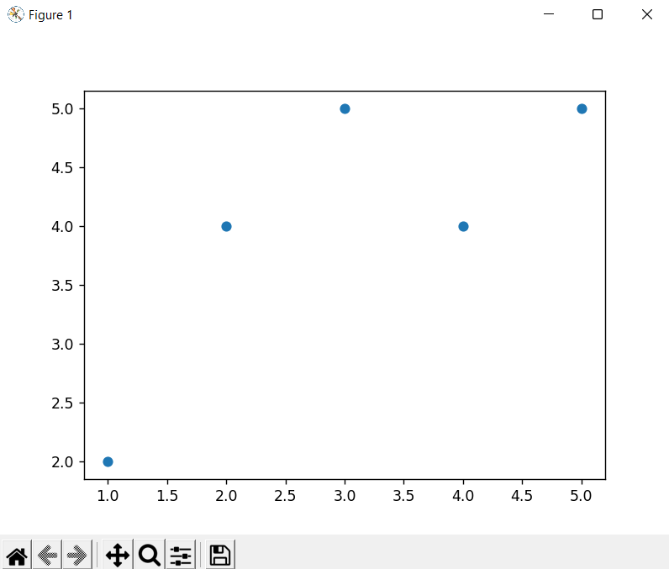

**{FINAL RESULT - Regression Line}**

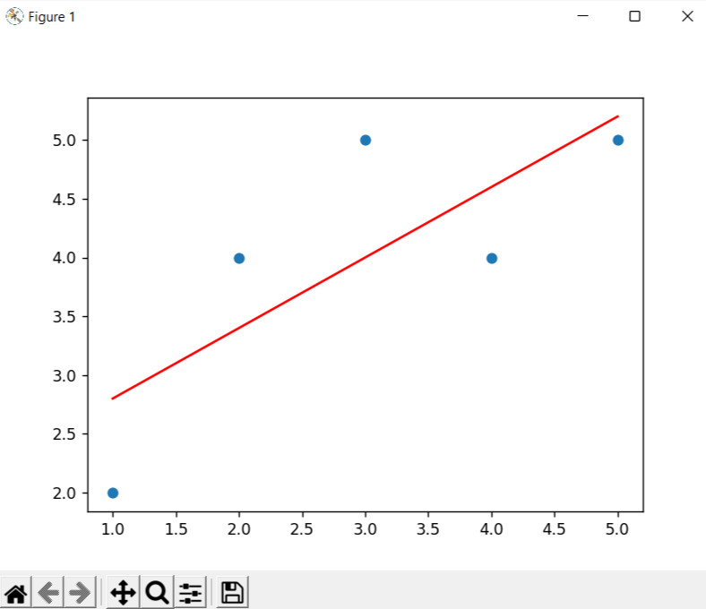

**OUTPUT :**

